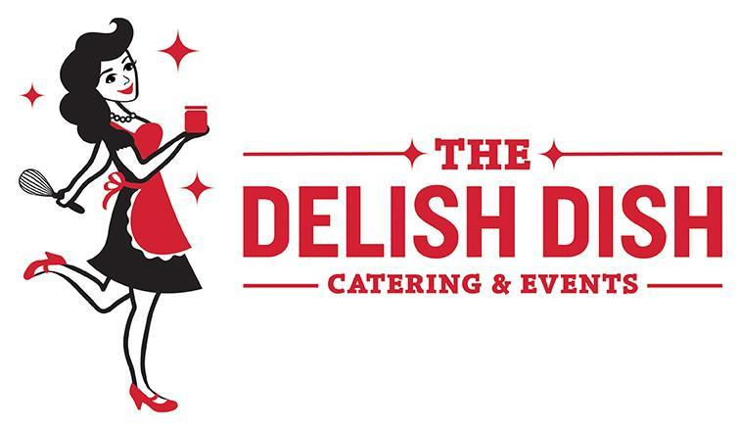

BEVERAGE MENU
Build Your Own Mimosa Bar (Choose 3 Juices)
Priced to order
You supply the Champagne, we bring everything else!
Orange, Grapefruit, Cranberry, Orange-Mango, Orange Pineapple
Oranges and mixed berries for garnish

A LA CARTE BEVERAGES
Mini Water Bottles … $1.00 pp
Water Bottles … $1.50 pp
Assorted Canned Sodas: Coke, Diet Coke, Sprite … $1.00 pp
Assorted Sodas & Mini Waters … $1.50 pp
Build Your Own Bloody Mary Bar
$5.00 per guest
You supply the vodka, we bring everything else!
Bloody Mary Mix, Celery, Hot Sauce (Frank’s Red Hot), Skewers with Cheese & Salami, Olives, Limes, and Bacon
FRESHLY PREPARED BEVERAGES (Minimum order of 3 gallons)
Fresh-Squeezed Lemonade …$25 per gal.
Fresh-Squeezed Lavender Lemonade ...$25 per gal.
Fresh-Squeezed Watermelon Lemonade …$25 per gal.
Flavored Waters: Choose from cucumber, lemon, or mixed berry …$10 per gal.
Iced Tea …$12 per gal.
Sweet Tea …$12 per gal.
Party Punch: Cranberry juice, sparkling cider, fresh squeezed lemon juice, and ginger ale collide in this addicting non-alcoholic punch, vodka optional. …$25 per gal.
Hot Chocolate Station
$5.00 per guest
Homemade Hot Chocolate, Bourbon Whipped Cream, Crushed Peppermints, Crushed Toffee Bars, Cinnamon, & Mini Marshmallows
COFFEE & TEA (Add disposable coffee cups & lids $.50)
Coffee Service: Decaf & regular, cream, milk, sugar, sweeteners, and stirrers …$1.50 pp
Ultimate Coffee Station: Coffee lovers delight! Features coffee from local café Coffee Emporium complete with an onsite barista ready to make your favorite gourmet coffee selection! 2-Hour Service …$350
3-Hour Service …$400
Hot Tea Service: An assortment of English style teas with cream, sugar, & lemon…$1.50 pp
Hot Tea & Coffee Service: Best of both worlds ...$2.00 pp
Hot Chocolate: …$3.50 pp

THE DELISH DISH SIGNATURE COCKTAILS
Sangria Station (Choose 1, 2, or all 3)
Priced to order
Pomegranate Rosé Sangria: This sangria combines the flavors of pomegranate, raspberries, strawberries, and plum to form a cocktail reminiscent of summer sippin' by the pool.
Hibiscus Red Sangria: This floral and slightly citrusy cocktail offers a fresh take on the classic red sangria.
White Peach Sangria: A refreshing summer drink that ups the ante with a splash of peach schnapps and floating summer fruit, this sangria will add sizzle to any get together.

Priced per person
Bourbon Barrel Apple Muddle: Bourbon, apple cider, muddled apple, whisky barrel bitters, and Made by Mavis Bourbon Barrel Stout Syrup. Garnished with an apple slice.
Bourbon Lavender Lemonade: Bourbon, honey, and Delish Dish lavender lemonade. Garnished with a sprig of lavender and a lemon twist.
Coconut-Lime Cooler: Rum, fresh squeezed lime juice, coconut water, and Made by Mavis Lime in the Coconut jam. Garnished with a lime and toasted coconut shavings.
DCR Chocolate Tini: Vodka, crème de cacao, half & half, and Made by Mavis Dark Chocolate Raspberry jam. Garnished with DCR jam and fresh raspberries.
Derby Cocktail: This classic cocktail marries bourbon with sweet vermouth, orange curacao or Grand Marnier, and fresh squeezed lime juice to produce a drink that's dry, tart, peppery, and subtly herbal. Garnished with mint leaves.
Pom-Pinot Tini: Vodka, pama liqueur, triple sec, Made by Mavis Pomegranate Pinot Noir jelly, Rose’s lime juice, and sprite. Garnished with an orange twist.
Strawberry Jamarita: Tequila, triple sec, strawberry margarita mix, and Made by Mavis Strawberry Basil jam. Garnished with a strawberry and a lime wedge.

Jamarita Station (Choose 1,2,3, or all 4)
Priced to order
Lime Margarita: The classic margarita! Tequila, triple sec, and sweet & sour
Strawberry Basil Jamarita: A fruity and herbaceous twist on the strawberry margarita Tequila, triple sec, strawberry margarita mix, and Made by Mavis Strawberry Basil jam
Blueberry Lime Jamarita: A sweet and refreshing take on the classic margarita Tequila, triple sec, sweet & sour, and Made by Mavis Blueberry Lime jam
Tropic Lightning Jamarita: This cocktail brings the heat with a hint of habanero Tequila, triple sec, pineapple juice, sweet & sour, and Made by Mavis Tropic Lightning jam

