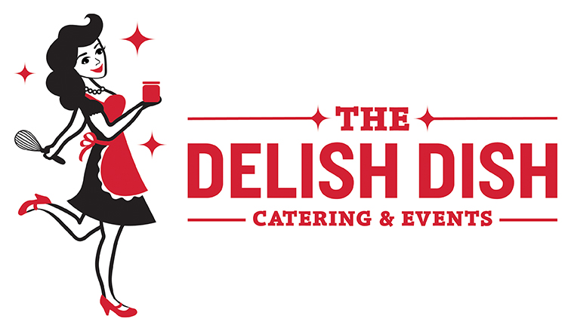
DESSERT MENU
Mini and Handheld Desserts
Banana Cream Pie Shooters: Creamy homemade banana cream pie in shooter pie
Bourbon S’mores Pot De Crème: Bourbon-chocolate mousse, grahams, marshmallow
Candied Bacon in a Shot Glass: With or w/o Guinness-Chocolate Dipping sauce (GF)
Cashew Baklava Cigars: A dainty version of our favorite Greek dessert with cashews
Chocolate Covered Strawberries: Elegance at its finest, milk or dark (GF)
NEW Cherry Cheesecakes: mini cheesecakes, vanilla wafer crust & sweet cherry topping
NEW Cookies & Crème Cheesecake: mini cheesecakes with an Oreo crust and Oreo topper
Crème Brûlée: Individual custards kissed with sugar and fire to make a crunchy top (GF)
Coconut Cream Pie Shooters: Served in a shooter glass. Creamy and made like Grandma’s!
Derby Pies: A mini version of the Southern classic. Bourbon. Chocolate. Pecans.
NEW Flourless Chocolate Tortes: rich, dainty, topped with a raspberry (GF)
Lemon Parfaits: Lemon curd, ladyfingers, whipped cream (GF upon request)
Pineapple Upside Down Cake Shooters: old-school perfection in a shot glass
Strawberry-White Chocolate Shooter: white chocolate mousse, lemon cream, berries (GF)
Tiramisu Parfaits: Individual parfaits with layers of mascarpone, ladyfingers, & espresso
Build Your Own Mini Dessert Bar
Mix and match mini desserts, mini cupcakes, and cookies to make a dessert bar with all of your favorite sweets! We suggest choosing 3-5 desserts.
COOKIES
NEW Buckeyes: an Ohio favorite! Creamy peanut butter candy dipped in chocolate
Brown Butter Chocolate Chip Cookies: our twist on the classic
Five-Spice Snickerdoodles (our signature cookie)
Grapefruit Vanilla Shortbread: Tender, buttery shortbread with grapefruit icing
Jam Thumbprint Cookies: filled with Made By Mavis artisan jams
NEW Italian Fig Cookie: old-fashioned cookie bars with Made by Mavis Bull F.R.O.G. Jam
Mexican Wedding Cookies: aka the snowball, powdered sugar-coated bite from heaven
Oatmeal Raisin Cookie: a childhood favorite
Peppermint Chocolate Ganache Cookie: fudgy cookies, fudgy glaze, and peppermint
NEW Red Velvet Sandwich: bite-size red velvet cookies wedged with cream cheese frosting
Triple-Chocolate Cranberry Oatmeal Cookies: a staff favorite!
Milk & Cookies Station
An adorable dessert or late-night station! Mini shot of cold milk with choice of cookie
BROWNIES & BARS
Brown Butter Rice Krispy Treats: Our favorite version of the classic
Chocolate-Covered Brown Butter Rice Krispy Pops: with colored sprinkles!
Dark Chocolate Raspberry Brownies: Our signature brownie, swirled with house jam
Double Chocolate Brownies: For those who appreciate dark chocolate and fudge
Fruity Pebble Crispies: our brown butter Rice Krispies with fruity pebbles mixed in
NEW Gluten-Free Chocolate Pecan Pie Bars: a bar version of the southern pie, delicious!
Gluten-Free Jam Bars: almond butter & Made by Mavis jam take this bar over the top (GF)
NEW Gluten-Free Chocolate Tahini Brownies: a modern spin on the fudgy brownie (GF)
Kahlúa Truffle Triangles: Coffee & rum-spiked dark chocolate truffle, shortbread crust
Key Lime Pie Bars: The classic pie in bite-size form with animal cracker crust
Nutella Rice Crispies: Yup. Hazelnut. Chocolate. Awesome!
Salted Peanut Butter & Jelly Bars: The classic in a sweet cookie with Made by Mavis jams
Signature Cheesecake Bars: Swirled with Made By Mavis artisan jams!
Pumpkin Cheesecake: A year-round favorite with graham cracker crust

CUPCAKES (available as mini or full size)
Cheesecake Bar (available gluten-free!)
A fun and interactive station for you and your guests! We provide individual cheesecake squares and you get to top them with an array of yummy toppings:
Guinness Chocolate Sauce, Salted Caramel Sauce, Bourbon Whipped Cream, Macerated Strawberries, and Blueberry-Lemon Fruit Topping
NEW Blackberry Panther Cupcakes: Lemon cake with Rhinegeist blackberry jam frosting
Double Chocolate Cupcakes: Chocolate cake with chocolate buttercream frosting, staff fave
Chocolate Cupcakes with Vanilla Buttercream: simple and sweet
NEW Chocolate Stout Cupcakes: topped with Made by Mavis Dead Blow Jam buttercream
Carrot Cake Cupcakes: Kitchen sink carrot cake cupcakes with cream cheese frosting
Maple Bacon Cupcakes: A pancake-like cupcake with Maple-Bacon Buttercream & BACON
Red Velvet Cupcakes: red velvet cake with homemade cream cheese frosting
NEW Peanut Butter Cup: PB cake, milk-chocolate swirl, PB cream cheese frosting
NEW Salted Caramel Cupcakes: filled with gooey salted caramel and a light fluffy frosting
Strawberry Dream Mini Cupcakes: Made with real strawberries in the cake and frosting
Vanilla Bean-Coconut Cupcakes: vanilla bean cupcakes with creamy coconut frosting
White Out Cupcakes: Vanilla Cupcakes with vanilla frosting, sprinkles on request
Cincinnati Dessert Station
Choose from Graeter’s Ice Cream Cups or Holtman’s Donut Holes on a Stick, in paper cones, or with a Dark Chocolate Raspberry Dipping Sauce. Or get both!

Cakes & Pies
Derby Pecan Pie: Bourbon. Chocolate. Pecans. Nom!
Kitchen Sink Carrot Cake: Pineapple, walnuts, cream cheese frosting
Peach Lavender Layer Cake: Homemade yellow cake, Peach Lavender Jam, buttercream
Pineapple-Upside Down Cake: Two-layer marvel with cherries and pineapple frosting
Red Velvet Cake with Cream Cheese Frosting: Available as cupcakes or Bundt cake
Strawberry Dream Cake: A strawberry lover’s two-layered heaven
Texas Sheet Cake: The biggest, fudgiest, tastiest chocolate sheet cake this side of Texas!
Tiramisu: Rum and espresso-soaked ladyfingers, mascarpone custard, whipped cream
Build Your Own French Crepe Station
Crepes made to order with nutella, macerated strawberries, blueberry-lemon topping, lemon curd, whipped cream, and powdered sugar
Custom Cake Pop Flavors
Chocolate
Vanilla
Red Velvet
Funfetti
Spiced Cake
* Bride and Groom designs available!
Naked Cakes
Naked cakes are the newest wedding dessert trend, and we’re so excited to offer these gorgeous cakes to our brides and clients. Choose your favorite cake flavor and icing. Fillings are optional! We can decorate with icing, flowers, or your own wedding cake topper.

CAKES
Chocolate, Vanilla, Carrot Cake, Funfetti, Lemon, Red Velvet

FROSTINGS
Vanilla Buttercream, Chocolate Buttercream, Cream Cheese, Pineapple

FILLINGS
Blueberry, Raspberry, Strawberry, or Made by Mavis Jams

