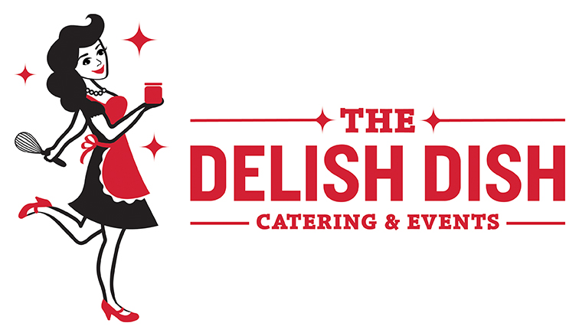
Corporate Catering Menu
Find our complete catering menu online at www.TheDelishDish.com

House Made Soups
Minimum order: 10 servings
Broccoli Cheddar Soup Gooey cheddar with broccoli and garlic $4.00/cup
Roasted Tomato & Basil Soup ♥ (GF)
Homemade tomato soup with fresh basil $4.00/cup
Pumpkin Turkey Chili ♥ $5.00/cup
Soup of the Day Ask about our soup special!

Jamwich™ Platters
An assortment of our most popular sandwiches. All platters come with pickles, utensils, plates, & napkins.
Small Platter - $98 (serves 10)
Medium Platter - $135 (serves 15)
Large Platter - $220 (serves 25)
UPGRADE your platter with potato chips ($1), local pretzels ($1.50, assorted desserts ($1.50), coffee ($2.00), soda & mini waters ($1.50)

♥Delish De-Light™ menu items under 500 calories. (Individual Jamwich™under 500 calories does not include sides)

Order today! Call 859.250.0881 or visit www.TheDelishDish.com
Jamwich™ Box Lunch $10.95
Jamwiches™ are unique wraps and sandwiches created with Made By Mavis™ artisan jams, jellies, and chutneys, as well as our handmade sauces and dressings. Served with a bag of Yankee Doodle Deli Gourmet Pretzels, homemade bread & butter pickles, and our signature Five-Spice Snickerdoodle cookie. Napkin and a mint are included.
Gluten-free bread available upon request (add $2)

Bourbon Barrel BLT Bourbon Barrel Stout Syrup, crispy bacon, tomato, spring mix, mayo on multigrain bread
The Kitchen Sink smoked turkey, cream cheese, Apple-Jalapeno Jelly, caramelized red onion, everything bagel
Pesto Chicken Wrap Moist roasted chicken breast, Greek Yogurt-Pesto dressing, celery, spinach, celery, and bell peppers wrapped in a flour tortilla
Buffalo Chicken Wrap Oven roasted chicken, tossed in our buffalo sauce, tomato, Monterey Jack, ranch and lettuce wrapped in a flour tortilla
Turkey & Cranberry♥ Oven roasted turkey, goat cheese, spring mix, and our Cranberry-Pear Chutney on ciabatta
Peace, Love & Hummus♥ Sautéed veggies, our house-made preserved lemon hummus and spring mix wrapped in a flour tortilla (VG)
Bring Home the Beef Thinly sliced roast beef, lemon-basil mayo, caramelized red onions, spring mix on ciabatta
We Be Hammin’ Ham and cheddar on a ciabatta roll with lettuce and our Bourbon Barrel Stout Syrup
Individual Lunch Salads
Add roasted chicken: $2. Comes with our signature Five-Spice Snickerdoodle cookie.
Harvest Salad♥ Spring mix, pears, blue cheese, craisins, sunflower seeds, honey-pepper balsamic dressing (GF, V) $10.95
House Salad♥ Cucumber, cherry tomato, roasted corn, red onion, and Green Goddess dressing (GF) $10.95
Strawberry Salad♥ Feta, strawberries, pecans, & homemade poppyseed dressing(GF,V) $10.95
Tuna Salad on Greens♥
Homemade white Albacore tuna salad served on a bed of field greens (GF) $8.95
Pesto Chicken on Greens♥ Moist roasted chicken breast, Greek Yogurt-Pesto Dressing, celery, spinach, & bell peppers served on top spring mix (GF) $8.95

Cold Sides
Small $30 (Serves 10) or Large $50 (Serves 20). Custom side dishes available.

Broccoli Salad♥ Bacon, cheddar, sunflower seeds, raisins, apple cider dressing (GF)
Corn & Bacon Potato Salad Your new favorite potato salad with dill-yogurt dressing (GF)
Kale and Apple Salad♥ Our new favorite side with poppy seed dressing (GF,V)
Lemon Orzo Salad♥ Fresh herbs and feta brighten up this salad (V)
Watermelon, Tomato & Feta Salad♥ Fresh herbs and lemon dressing (V, GF)

Breakfast Options
Contact us for pricing. Minimum order: 10 guests

Breakfasts Burritos
Individually wrapped, served with salsa & sour cream
- Sausage, Pepper, & Onion Burrito
- Potato, Poblano, & Onion Burrito (V)
- Spinach, Mushroom, & Feta Burrito (V)

Breakfast Bakes & Casseroles
Most available gluten-free upon request
- Asparagus & Mushroom (V)
- Chorizo & Potato
- Everything Bagel with Sausage
- Smoked Salmon with Potatoes & Herbs
- Spinach & Feta (V)
- Southwestern (Sausage, Pepper, Onion)

Quiches or Mini Frittatas
Frittatas (GF) are muffin size; we suggest 2 per person. Quiches are full pies or bite-size.
- Ham & Cheddar with Basil
- Quiche Lorraine (bacon, onion, Swiss)
- Spinach & Feta (V)
- Red Pepper & Goat Cheese (V)

French Toast Casserole
With streusel topping, served with maple syrup (V)

Mini Scone Platter♥ A mix of our homemade cranberry, blueberry, chocolate chip, and/or vanilla bean scones (V)

Yogurt & Berry Parfaits♥
Fresh strawberries, blueberries, Honey Greek yogurt and topped with Whirly Bird Granola (V)
Order today! Call 859.250.0881 or visit www.TheDelishDish.com
Some like it Hot…
Contact us for pricing. Minimum order: 10 guests
Slider Bar
Slider bar (choose 2-3) comes with slider and pretzel buns, coleslaw & homemade bread & butter pickles.
Apple Cider Pulled Chicken (GF)
Barbeque Beef Brisket (GF)
Black Bean Sliders w/Chipotle Mayo
Buffalo Pulled Chicken (GF)
Maple-Espresso Pulled Pork (GF)

Italian Inspiration
Butternut Squash Lasagna Rolls
Bacon & Parmesan Pasta
Classic Lasagna
Pasta Primavera (chicken optional)
Italian Sausage Mostaccoli
Vegetable Lasagna
Slow-Roasted Italian Pork with root vegetables and white wine sauce (GF)
Roman Style Chicken white-wine braised chicken with prosciutto, peppers, onions, and tomatoes (GF)

Taco Bar
Option to add Cilantro-Lime Rice & Black Beans
Beef Piccadillo (GF)
Adobo Pulled Chicken (GF)
Adobo Pulled Pork (GF)
Cilantro-Lime Jackfruit (V, GF)
Potato, Poblano & Corn (V,GF)
Pork Carnitas (GF)
*Taxes & Delivery not included in pricing; 10 guests or $100.00 minimum order. Orders with less than 48-hours notice may incur a fee.
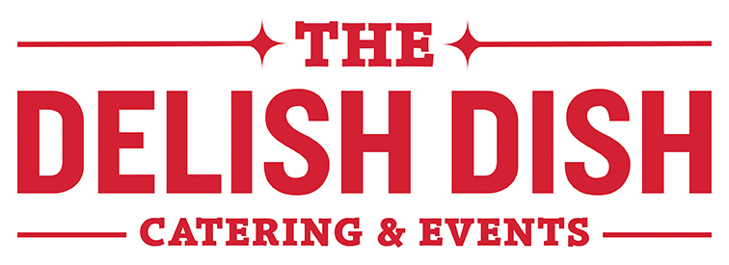

Corporate Catering Menu
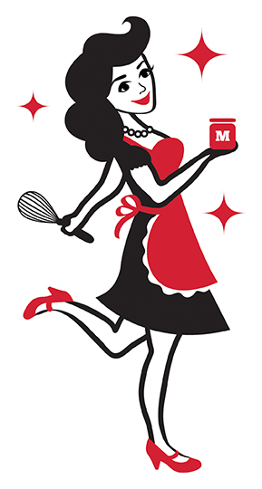

Find our complete catering menu online at www.TheDelishDish.com

Order via phone or email:
859.250.0881
Mavis@thedelishdish.com

