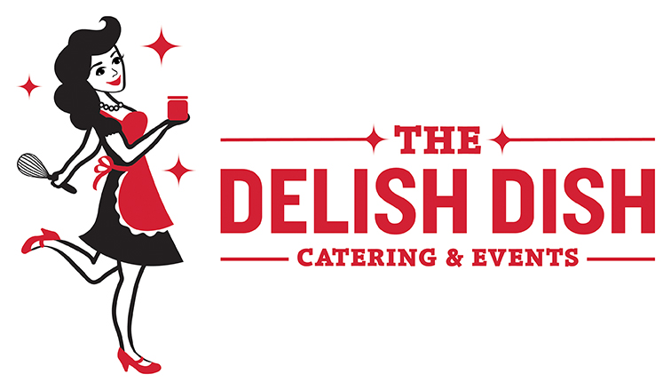

A LA CARTE BREAKFAST
Priced to order. Minimum order: 10 guests.

Breakfast Burritos
Individually wrapped egg-based burritos, served with salsa & sour cream
- Sausage, Pepper, & Onion
- Potato, Poblano, & Corn (V)
- Spinach, Mushroom, & Feta (V)

Breakfast Bakes & Casseroles
- Asparagus & Mushroom (V, GF)
- Chorizo & Potato with Peppers & Onions (GF)
- Everything Bagel with Sausage OR Mushrooms (V)
- French Toast Casserole with Streusel Toppings & Maple Syrup
- Smoked Salmon with Potatoes & Herbs (GF)
- Spinach & Feta (V, GF)
- Southwestern with Sausage, Peppers, Onions

Quiches or Mini Frittatas
Frittatas are muffin size (GF); we suggest 2 per person. Quiches are full pies or bite-size, NOT gluten-free.
- Ham & Cheddar with Basil
- Quiche Lorraine (bacon, caramelized onions, Swiss cheese)
- Spinach & Feta (V)
- Red Pepper & Goat Cheese (V)

Breakfast Meats
- Hickory-Smoked Bacon
- Sausage Patties
- Goetta
- Candied Bacon in a Shot Glass
- Pineapple Glazed Ham

Biscuits (V)
- Buttermilk
- Blue Cheese
- Chive
- Sweet Potato
- Cornmeal
- Available in full or mini size
- Combine 2-4 for a Biscuit Bar!

Scones (V)
- Cranberry
- Blueberry
- Chocolate chip
- Vanilla bean,
- Pumpkin spice latte
- Available in full or mini size
- Combine 2-4 for a Scone Bar!

Salads, Fruit, & Yogurt
- Cheesy Grits
- Seasonal Fresh Fruit Salad
- Strawberry Spinach Salad
- Fruit & Cheese Kabobs
- Individual Flavored Yogurts
- Yogurt & Berry Parfaits: strawberries, blueberries, Honey Greek yogurt and topped with Whirly Bird Granola (V), available mini or full size.

BREAKFAST STATIONS
Our stations add a fun and interactive element to your brunch celebration!

BISCUIT BAR
Choice of biscuit(s): buttermilk, blue cheese, cornmeal, sweet potato, or chive. Available in mini or full-size. We pair them with butter and Made by Mavis jams OR your favorite toppings including: sausage gravy, Sriracha aioli, country ham,
pepper steak, roasted turkey, and a variety of mustards.

FRENCH CREPE STATION
Crepes made to order with custom toppings: Nutella, macerated strawberries, blueberry-lemon topping, lemon curd, whipped cream, and powdered sugar

MINI DESSERT STATION
Mix and match our homemade mini desserts, mini cupcakes, and
cookies to make a dessert bar with all your favorite sweets! We suggest 3-5 desserts.

MINI SCONE AND JAM BAR (V)
A variety of our mini scones with Made by Mavis Jams and butter to pair with them!

OMELET BAR
Our chefs will make omelets to order and guest can choose from a variety of fillings.

PANCAKE OR WAFFLE BAR (V)
Fluffy pancakes with an array of toppings: fresh fruit, Made by Mavis jams whipped cream, chocolate chips, Made By Mavis Bourbon Barrel Stout Syrup, maple syrup, Nutella, powdered sugar and/or butter

SHRIMP & GRITS BAR
This Deep South-inspired station includes the very best North Carolina Grits, garlic-roasted shrimp, bacon, chives, cheddar, and whatever else you can dream up to put on your grits!

